**Dr. B R AMBEDKAR NATIONAL INSTITUTE OF TECHNOLOGY JALANDHAR**



**LAB FILE OF**

**DATA STRUCTURES AND**

**ALGORITHMS**

SESSION 2017-2021

**Submitted To: Submitted By:**

DR. RAJNEESH RANI Ankit Goyal

ASST.PROFESSORRoll no.-17103011

Computer Science and Engineering Group- G1

NIT JALANDHAR

**INDEX**

|  |  |  |  |  |
| --- | --- | --- | --- | --- |
| **S.no.** | **Program name** | **Page no.** | **Date** | **Remarks** |
| 1 | Write a program to insert, delete, sorting, counting frequency in an array. | 5-9 |  |  |
| 2(a) | Write a program to reverse array, linear search and binary search in array. | 10 |  |  |
| 2(b) | Write a program to multiply two matrices using array. | 11-13 |  |  |
| 2(c) | Write a program to implement sparse matrix and find transpose. | 14-15 |  |  |
| 3(a) | Write a program to add two sparse matrices. | 16-17 |  |  |
| 3(b) | Write a program to multiply two sparse matrices. | 18-19 |  |  |
| 3(c) | Write a program to create and traverse list, find min and max, double the values, sum of previous element and perform insertion and deletion at beginning ,middle and end. | 20-22 |  |  |
| 4 | Write a program to swap nodes (consecutive and non-consecutive ) ,reverse the list, concatenate list, splitting list and find frequency of elements in sorted and unsorted list. | 23-28 |  |  |
| 5 | Write a program to create doubly linked list and perform insertion , deletion and print in forward and reverse direction | 29-34 |  |  |
| 6.1 | Write a program to add polynomials using linked list. | 35-38 |  |  |
| 6.2(a) | Write a program to multiply polynomials using linked list. | 39-41 |  |  |
| 6.2(b) | Write a program to implement basic operations (push, pop, display) of stack using array. | 42-44 |  |  |
| 7.1 | Write a program to implement basic operations (push, pop, display) of stack using linked list. | 45-46 |  |  |
| 7.2(a) | Write a program which performs postfix evaluation. | 47-49 |  |  |
| 7.2(b) | Write a program to convert infix to postfix expression. | 50-51 |  |  |
| 7.3 | Write a program to convert decimal number to octal number. | 52-53 |  |  |
| 8.1 | Write a program to sort elements using quick sort using stack. | 54-57 |  |  |
| 8.2(a) | Write a program to find GCD of two numbers. | 58 |  |  |
| 8.2(b) | Write a program to sort elements using quick sort using stack. | 59-60 |  |  |
| 8.2(c1) | Write a program to find factorial of number using tail recursion. | 61 |  |  |
| 8.2(c2) | Write a program to find factorial of number using non-tail recursion. | 62 |  |  |
| 8.2(d1) | Write a program to find fibonacci series  Using tail recursion. | 63 |  |  |
| 8.2(d2) | Write a program to find fibonacci series  Using non-tail recursion. | 64 |  |  |
| 9.1 | Write a program to implement basic operations (Insert,Delete and display) of queue using array . | 65-67 |  |  |
| 9.2 | Write a program to implement basic operations (Insert,Delete and display) of queue using linked list. | 68-70 |  |  |
| 9.3(a) | Write a program to implement input restricted queue. | 71-73 |  |  |
| 9.3(b) | Write a program to implement output restricted queue. | 74-76 |  |  |
| 9.4(a) | Write a program to implement priority queue by array. | 77-80 |  |  |
| 9.4(b) | Write a program to implement priority queue by linked list. | 81-83 |  |  |
| 10.1 | Write a program to implement insertion, deletion, height of tree in binary tree. | 84-88 |  |  |
| 10.2 | Write a program to implement insertion, deletion, height of tree in binary search tree. | 89-91 |  |  |
| 11 | Write a program to insertion, traversal, in AVL tree. | 92-94 |  |  |
| 12.1 | Write a program to implement insertion, deletion, and sorting in Heap. | 95-96 |  |  |
| 12.2 | Write a program to implement insertion, deletion of edge and display Graph. | 97-98 |  |  |
| 13.1(a) | Write a program to find path matrix using powers of matrix. | 99-101 |  |  |
| 13.1(b) | Write a program to find path matrix using Warshall algorithm. | 102-104 |  |  |
| 13.2(c) | Write a program to implement Breadth first and Depth first search. | 105-109 |  |  |
| 13.3 | Write a program to find shortest path using Dijkstra algorithm. | 110-112 |  |  |

1. **Write a program to implement**
2. **Insertion in an Array**
3. **deletion in an Array**
4. **Sorting elements of an array**
5. **Count the frequency of elements**

#include<iostream>

#include<stdlib.h>

using namespace std;

void sorting(int*,int);

void insertion_beg(int *no,int *n)

{

int i;

for(i=(*n)-1;i>=0;i--)

{

no[i+1]=no[i];

}

cout<<"enter the no. u want to insert :\n";

cin>>no[0];

*n=(*n)+1;

}

void insertion_mid(int *no,int *n)

{

int i,temp;

cout<<"enter the index at which u want to insert :\n";

cin>>temp;

for(i=*(n)-1;i>=temp;i--)

{

no[i+1]=no[i];

}

cout<<"enter the no u want to insert :\n";

cin>>no[temp];

*n=(*n)+1;

}

void insertion_end(int *no,int *n)

{

cout<<"enter the element u want to insert :\n";

cin>>no[*n];

*n=(*n)+1;

}

void delete_mid(int *no,int *n)

{

int i,temp;

cout<<"enter the index at which u want to delete :\n";

cin>>temp;

for(i=temp+1;i<*n;i++)

{

no[i-1]=no[i];

}

*n=(*n)-1;

}

void delete_element(int *no,int *n) //deletion in array

{

int temp,i,j;

cout<<"enter the element u want to delete\n";

cin>>temp;

for(i=*n-1;i>=0;i--)

{

if(temp==no[i])

{

for(j=i+1;j<*n;j++)

{

no[j-1]=no[j];

}

i--;

*n=(*n)-1;

}

}

}

void sorting(int *no,int n) //sorting

{

int i,j,c=0,temp;

for(i=0;i<n;i++)

{

for(j=i+1;j<n;j++)

{

if(no[j]<no[i])

{

temp=no[j];

no[j]=no[i];

no[i]=temp;

c++;

}

}

}

cout<<"your array has been sorted in" <<c<<"steps\n";

}

void freq(int *no,int n,int x) //frequency of element

{

int i,c=0;

for(i=0;i<n;i++)

{

if(no[i]==x)

c++;

}

cout<<x<<"appeared "<<c<<"times\n";

}

int main()

{

int n,i;

cout<<"enter the length of array: ";

cin>>n;

cout<<"enter the elements of array";

int no[100],temp;

for(i=0;i<n;i++)

{

cin>>no[i];

}

cout<<"\n\n1 for insertion at beg.\n2 for insertion in mid\n3 for insertion at end\n";

cout<<"4 for deletion at end\n5 for deletion at mid\n6 for deleting an element from complete array\n7 for sorting\n8 for print\n9 for frequency \n10for exit\n ";

while(1)

{

int flag=0,c=0,lb,ub,c_b=0;

cout<<"\nenter your choice :";

int ch,j=0;

cin>>ch;

switch(ch)

{

case 1:

insertion_beg(no,&n);

break;

case 2:

insertion_mid(no,&n);

break;

case 3:

insertion_end(no,&n);

break;

case 4:

n=n-1;

break;

case 5:

delete_mid(no,&n);

break;

case 6:

delete_element(no,&n);

break;

case 7:

sorting(no,n);

break;

case 8:

print(no,n);

break;

case 9:

cout<<"enter the no. u want to search: ";

int x;

cin>>x;

freq(no,n,x);

break;

case 10:

exit(0);

break;

default:

cout<<"enter correct choice\n";

}

}

}

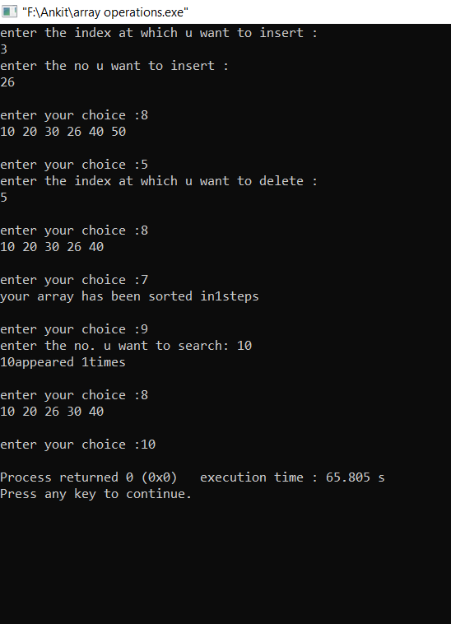

**2.(a) Write a program to reverse an Array without using extra storage.**

#include<iostream>

using namespace std;

int main()

{

int n, i, a[10];

cout<<"Enter total number of elements ";

cin>>n;

cout<<"enter elements of array ";

for(i=0; i<n; i++)

{

cin>>a[i];

}

for(i=0;i<n/2;i++)

{

a[i]=a[i]+a[n-1-i];

a[n-1-i]=a[i]-a[n-1-i];

a[i]=a[i]-a[n-1-i];

}

cout<<"reversed array";

for(i=0; i<n; i++)

{

cout<<a[i]<<" ";

}

return 0;

}

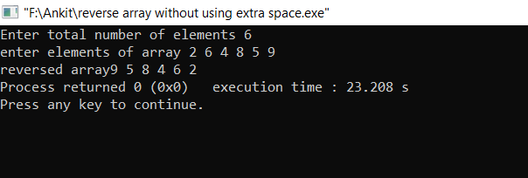

**2.(b) Write a program to implement linear and binary search.**

#include<iostream>

Using namespace std;

void binarysearch(int *no,int n)

{

sorting(no,n);

int temp,i,flag=0,c_b=0;

cout<<"enter the no. u want to search :\n";

cin>>temp;

int lb=0,ub=n-1;

while(ub>=lb)

{

if(temp>no[(ub+lb)/2])

{

lb=((ub+lb)/2)+1;

c_b++;

}

else if(temp<no[(ub+lb)/2])

{

ub=((ub+lb)/2)-1;

c_b++;

}

else if(temp==no[(ub+lb)/2])

{

c_b++;

flag=1;

break;

}

}

if(flag==1)

cout<<"yes"<<" couter="<<c_b<<"\n";

else

cout<<"no\n";

}

void linear_search(int *no,int n)

{

int temp,i,j,flag;

cout<<"enter the no. u want to search :\n";

cin>>temp;

for(i=0;i<n;i++)

{

if(temp==no[i])

{

flag=1;

break;

}

}

if(flag==1)

cout<<"yes it is present \n";

else

cout<<"no it is not present\n" ;

}

int main()

{

int n,i;

cout<<"enter the length of array: ";

cin>>n;

cout<<"enter the elements of array";

int no[100],temp;

for(i=0;i<n;i++)

{

cin>>no[i];

}

int ch;

cout<<" 1 for linear search \n 2 for binary search \n 3 for exit";

while(1)

{

cout<<"\nenter your choice :";

cin>>ch;

switch(ch)

{

case 1:

linear_search(no,n);

break;

case 2:

binarysearch(no,n);

break;

case 3:

exit(0);

}

}

}

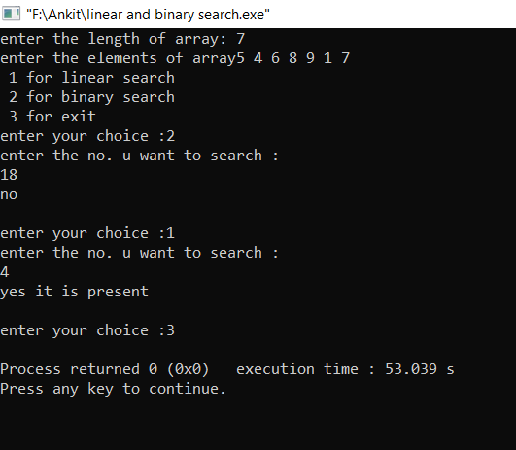

**2.(c) Write a program for matrix multiplication.**

#include<iostream>

using namespace std;

int main()

{

int m,n;

cout<<"enter order of mat1\n";

cin>>m>>n;

int q,p;

cout<<"enter order of mat2\n";

cin>>q>>p;

if(n!=q)

cout<<"matrix are not multiplicable\n";

else

{int a[m][n],b[n][p],c[m][p],i,j,k;

cout<<"enter elements of mat1\n";

for(i=0;i<m;i++)

for(j=0;j<n;j++)

cin>>a[i][j];

cout<<"enter elements of mat 2\n";

for(i=0;i<n;i++)

for(j=0;j<p;j++)

cin>>b[i][j];

for(i=0;i<m;i++)

{

for(j=0;j<p;j++)

{

c[i][j]=0;

for(k=0;k<n;k++)

{

c[i][j]=c[i][j]+(a[i][k]*b[k][j]);

}

}

}

cout<<"required matrix is:\n";

for(i=0;i<m;i++)

{for(j=0;j<p;j++)

{cout<<c[i][j]<<" ";}

cout<<"\n";}

}

}

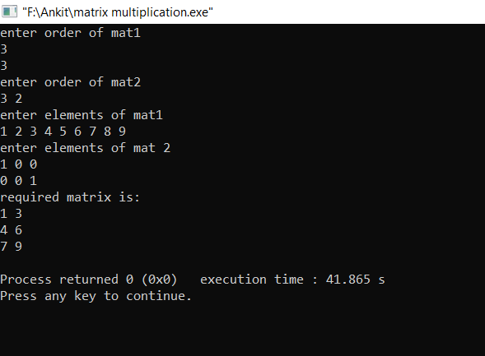

**3.(a) Write a program to implement sparse matrix and transpose of matrix.**

#include<iostream>

using namespace std;

struct sparse

{

int r,c,v;

};

void getinput(sparse *s,int x)

{

cout<<"enter the order of matrix :\n";

int n,m;

cin>>n>>m;

s[0].r=n;s[0].c=m;s[0].v=x;

cout<<"enter row ,column and value of matrix :\n";

int i;

for(i=1;i<=x;i++)

{

cin>>s[i].r>>s[i].c>>s[i].v;

}

}

void transpose(sparse *s)

{

int i;

for(i=0;i<=s[0].v;i++)

{

int temp=s[i].r;

s[i].r=s[i].c;

s[i].c=temp;

}

}

void print(sparse *s)

{

int i,j,k;

for(i=0;i<s[0].r;i++)

{

for(j=0;j<s[0].c;j++)

{

int flag=0;

for(k=1;k<=s[0].v;k++)

{

if(i==s[k].r && j==s[k].c)

{

flag=1;

break;

}

}

if(flag==1)

cout<<s[k].v<<" ";

else

cout<<0<<" ";

}

cout<<"\n";

}

}

int main()

{

cout<<"enter the no. of non zero elements: ";

int n;

cin>>n;

sparse s1[n+1];

getinput(s1,n);

cout<<"enter the no. of non zero elements: ";

cin>>n;

sparse s2[n+1];

getinput(s2,n);

cout<<"before transpose :\n";

print(s1);

transpose(s1);

cout<<"after transpose :\n";

cout<<"\n";

print(s1);

}

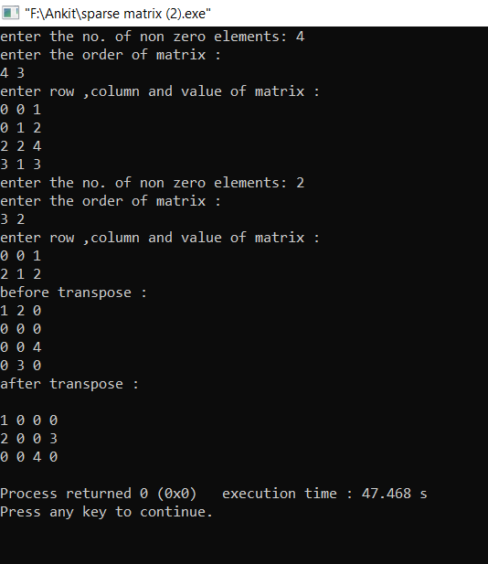

**3.(b) Write a program for matrix addition using sparse.**

#include<iostream>

using namespace std;

main()

{

int m1,n1,t1,t2;

cout<<"enter order of matrix 1\n";

cin>>m1>>n1;

cout<<"enter no. of non zero elements in matrix 1\n";

cin>>t1;

int mat1[t1][3];

cout<<"enter row, column, value of each element for mat 1\n";

for(int i=0;i<t1;i++)

for(int j=0;j<3;j++)

cin>>mat1[i][j];

cout<<"\n\n\n";

cout<<"enter no. of non zero elements for mat 2\n";

cin>>t2;

int mat2[t2][3];

cout<<"enter row, column, value of each element for mat 2\n";

for(int i=0;i<t2;i++)

for(int j=0;j<3;j++)

cin>>mat2[i][j];

cout<<"\n\n\naddition of matrices is:\n";

int mat[m1][n1];

for(int i=0;i<m1;i++)

{

for(int j=0;j<n1;j++)

{

mat[i][j]=0;

for(int k=0;k<t1;k++)

{

if(mat1[k][0]==i&&mat1[k][1]==j)

{

mat[i][j]+=mat1[k][2];

break;

}

}

for(int k=0;k<t2;k++)

{

if(mat2[k][0]==i&&mat2[k][1]==j)

{

mat[i][j]+=mat2[k][2];

break;

}

}

cout<<mat[i][j]<<" ";

}

cout<<"\n";

}

}

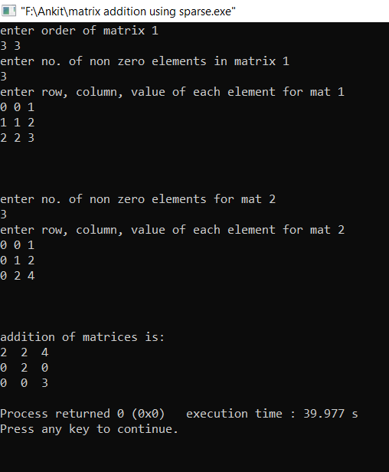

**3.(c) Write a program to multiply sparse matrices.**

#include<iostream>

using namespace std;

struct sparse

{

int r,c,v;

};

void getinput(sparse *s,int x)

{

cout<<"enter the order of matrix :\n";

int n,m;

cin>>n>>m;

s[0].r=n;s[0].c=m;s[0].v=x;

cout<<"enter row ,column and value of matrix :\n";

int i;

for(i=1;i<=x;i++)

{

cin>>s[i].r>>s[i].c>>s[i].v;

}

}

void transpose(sparse *s)

{

int i;

for(i=0;i<=s[0].v;i++)

{

int temp=s[i].r;

s[i].r=s[i].c;

s[i].c=temp;

}

}

void print(sparse *s)

{

int i,j,k;

for(i=0;i<s[0].r;i++)

{

for(j=0;j<s[0].c;j++)

{

int flag=0;

for(k=1;k<=s[0].v;k++)

{

if(i==s[k].r && j==s[k].c)

{

flag=1;

break;

}

}

if(flag==1)

cout<<s[k].v<<" ";

else

cout<<0<<" ";

}

cout<<"\n";

}

}

void mult(sparse *m1,sparse *m2,sparse *m3)

{

transpose(m2);

int c=0;

m3[0].r=m1[0].r;

m3[0].c=m2[0].r;

int i,j,k,l,sum;

for(i=0;i<m1[0].r;i++)

{

for(j=0;j<m2[0].r;j++)

{

sum=0;

for(k=1;k<=m1[0].v;k++)

{

if(m1[k].r==i)

{

for(l=1;l<=m2[0].v;l++)

{

if(m2[l].r==j)

{

if(m2[l].c==m1[k].c)

{

sum=sum+((m1[k].v)*(m2[l].v));

}

}

}

}

}

if(sum!=0)

{

c++;

m3[c].r=i;

m3[c].c=j;

m3[c].v=sum;

}

}

}

m3[0].v=c;

}

int main()

{

cout<<"enter the no. of non zero elements: ";

int n;

cin>>n;

sparse s1[n+1];

getinput(s1,n);

cout<<"enter the no. of non zero elements: ";

cin>>n;

sparse s2[n+1];

getinput(s2,n);

sparse s3[(s1[0].r)*(s2[0].c)+1];

mult(s1,s2,s3);

cout<<"\nafter multiplication matrix is :\n";

print(s3);

}

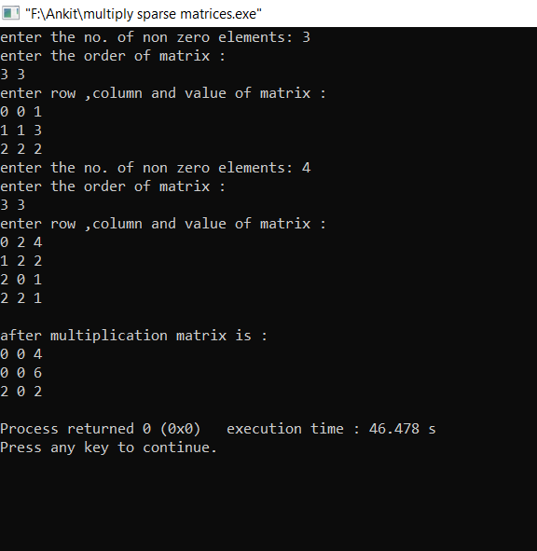

**4. Write a program to implement**

* 1. **Create and Traverse a Singly linked list**
  2. **Double of original value of Linked List**
  3. **Sum of previous elements of linked list**
  4. **Find Min and Max element from integer Linked List**
  5. **Insertion in a Singly Linked List at Beginning, middle and end position**
  6. **Deletion of node from beginning , middle and end of list**

#include<iostream>

#include<stdlib.h>

using namespace std;

struct node

{

int data;

node *next;

};

node* create(int n)

{

node *temp=new node;

temp->next=NULL;

temp->data=n;

return temp;

}

void insertion(node **head,int n) //insertion

{

node *temp=*head;

if(temp==NULL)

{

*head=new node;

(*head)->data=n;

(*head)->next=NULL;

}

else

{

while((temp)->next!=NULL)

{

(temp)=(temp)->next;

}

(temp)->next=new node;

(temp)->next->next=NULL;

(temp)->next->data=n;

}

}

void print(node *temp)

{

while(temp!=NULL)

{

cout<<temp->data<<"\n";

temp=temp->next;

}

}

void double_value(node *temp)

{

while(temp!=NULL)

{

temp->data=temp->data*2;

temp=temp->next;

}

}

void sum(node *temp)

{

int sum=0;

while(temp!=NULL)

{

sum=temp->data+sum;

temp->data=sum;

temp=temp->next;

}

}

void sum_last(node *temp)

{

int sum,x;

while(temp!=NULL)

{

x=temp->data;

temp->data=x+sum;

sum=x;

temp=temp->next;

}

}

int largest(node *temp) //largest

{

int largest=temp->data;

while(temp!=NULL)

{

if(largest<temp->data)

{

largest=temp->data;

}

temp=temp->next;

}

return largest;

}

int smallest(node *temp)

{

int smallest=temp->data;

while(temp!=NULL)

{

if(lsmallest>temp->data)

{

smallest=temp->data;

}

temp=temp->next;

}

return smallest;

}

void deletion_begin(node **head) //deletion at begin

{

node *temp=*head;

if(temp==NULL)

cout<<"list is already empty.";

else

{

temp=temp->next;

delete head;

*head=temp;

}

}

void deletion_end(node *head) //deletion at end

{

node *temp,*t;

temp=head;

if(temp==NULL)

cout<<"List is already empty";

else

{

while(temp->next!=NULL)

{

t=temp->next;

if(t->next==NULL)

break;

else

temp=temp->next;

}

temp->next=NULL;

delete t;

}

}

void deletion_mid(node *head) //deletion in mid

{

node *temp,*t;

int n;

cout<<"enter the data you want to delete";

cin>>n;

temp=head;

if(temp==NULL)

cout<<"list is empty";

else

{

t=temp->next;

cout<<"\n\n\n"<<t->next;

while(t->next!=NULL)

{

t=temp->next;

if(t->data!=n)

temp=temp->next;

else

{

temp->next=t->next;

break;

}

}

if(t->data==n && t->next==NULL)

cout<<"\nend of list\n";

else if(t->next==NULL)

cout<<"\nwrong input\n";

}

}

int main()

{

node *head=NULL;

int ch,x,y;

cout<<"1 insertion \n2 largest\n3 least elmenent\n4double each value\n5 previous elements sum\n6 sum only last one\n7 print\n8 deletion at beg\n;

cout<<"9 deletion_mid \n10 deletion end\n11 exit\n";

while(1)

{

cout<<"enter your choice :";

cin>>ch;

switch(ch)

{

case 1:

cout<<"enter data :";

cin>>x;

insertion(&head,x);

break;

case 2:

y=largest(head);

cout<<y<<"\n";

break;

case 3:

y=smallest(head);

cout<<y<<"\n";

break;

case 4:

double_value(head);

break;

case 5:

sum(head);

break;

case 6:

sum_last(head);

break;

case 7:

print(head);

break;

case 8:

deletion_begin(&head);

break;

case 9:

deletion_mid(head);

case 10:

deletion_end(head);

case 11:

exit(0);

break;

default:

cout<<"enter correct choice :";

}

}

}

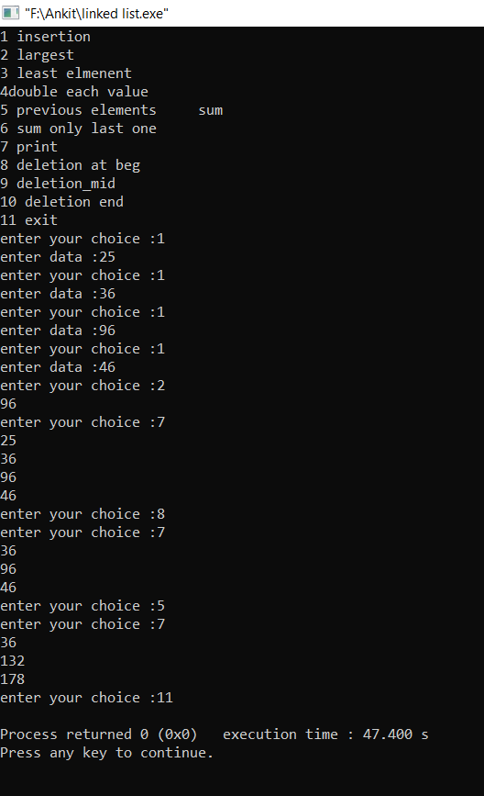

1. **Write a program to implement**
2. **Frequency of elements in sorted and unsorted linked list**
3. **Swapping of 2 nodes in a linked list for consecutive and non-consecutive nodes**
4. **Reverse a Singly Linked List**
5. **Concatenation of two Linked list**
6. **Splitting of linked list in even and odd elements list**

#include<iostream>

#include<stdlib.h>

using namespace std;

struct node

{

int data;

node *next;

};

void insertion(node **,int );

node* create(int n)

{

node *temp=new node;

temp->next=NULL;

temp->data=n;

return temp;

}

node *createlist()

{

int i,n,x;

cout<<"enter the length of 1 list :";

cin>>n;

cout<<"enter the data :";

cin>>x;

node *temp1=create(x);

for(i=1;i<n;i++)

{

cin>>x;

insertion(&temp1,x);

}

return temp1;

}

void insertion(node **head,int n) //insertion of node

{

node *temp=*head;

if(temp==NULL)

{

*head=new node;

(*head)->data=n;

(*head)->next=NULL;

}

else

{

while((temp)->next!=NULL)

{

(temp)=(temp)->next;

}

(temp)->next=new node;

(temp)->next->next=NULL;

(temp)->next->data=n;

}

}

void print(node *temp)

{

while(temp!=NULL)

{

cout<<temp->data<<" ";

temp=temp->next;

}

cout<<"\n";

}

void freq_sorted(node *temp) //freq in sorted list

{

int c=1;

while(temp->next!=NULL)

{

int x=temp->data;

if(temp->data==temp->next->data)

{

c++;

}

else

{

cout<<temp->data<<"-"<<c<<"\n";

c=1;

}

temp=temp->next;

if(temp->next==NULL)

{

cout<<temp->data<<"-"<<c<<"\n";

}

}

}

void freq_unsorted(node *head) //freq in unsorted list

{

node *temp1=head,*temp2;

while(temp1!=NULL)

{

temp2=temp1->next;

int c=1;

while(temp2!=NULL)

{

if(temp1->data==temp2->data)

{

c++;

temp2->data=temp2->next->data;

temp2->next=temp2->next->next;

}

else

temp2=temp2->next;

}

cout<<temp1->data<<" - "<<c<<"\n";

temp1=temp1->next;

}

}

void reverselist(node **head)

{

node *temp=*head,*t;

while(temp->next!=NULL)

{

t=temp->next;

temp->next=t->next;

t->next=*head;

*head=t;

}

}

node* concatenate()

{

node *temp1=createlist(),*temp2=createlist();

node *t=temp1;

while(temp1->next!=NULL)

{

temp1=temp1->next;

}

temp1->next=temp2;

return t;

}

node* swapnode(node *start,int x)

{

int i;

node *temp1,*temp,*temp2;

temp=start;

if(x>=2)

{

for(i=0;i<x-2;i++)

{

temp=temp->next;

}

temp2=temp;

temp=temp->next;

temp1=temp;

temp=temp->next;

temp1->next=temp->next;

temp->next=temp1;

temp2->next=temp;

}

else

{

start=temp->next;

temp->next=start->next;

start->next=temp;

}

return start;

}

node* swap_nc(node *start,int x,int y) //swaping of nodes

{

int i;

node *temp,*temp1,*temp2,*temp3;

temp=start;

if(x>=2)

{

for(i=0;i<x-2;i++)

temp=temp->next;

temp2=temp->next->next;

temp1=temp2;

for(i=0;i<y-x-2;i++)

temp1=temp1->next;

temp3=temp1->next;

temp->next->next=temp3->next;

temp1->next=temp->next;

temp->next=temp3;

temp3->next=temp2;

}

else

{

temp1=temp;

temp2=temp->next;

for(i=0;i<y-2;i++)

temp1=temp1->next;

start=temp1->next;

temp1->next=temp;

temp->next=start->next;

start->next=temp2;

}

return start;

}

void splitting(node *head)

{

node *temp=head,*temp1=head->next,*temp3;

while(temp!=NULL && temp->next!=NULL && temp->next->next!=NULL)

{

cout<<temp->data<<" ";

temp=temp->next->next;

}

if(temp!=NULL)

cout<<temp->data<<" ";

while(temp1!=NULL && temp1->next!=NULL && temp1->next->next!=NULL)

{

cout<<temp1->data<<" ";

temp1=temp1->next->next;

}

if(temp1!=NULL)

cout<<temp1->data<<" ";

cout<<"\n";

}

int main()

{

cout<<" 1 for frequency in sorted \n 2 for frequency in unsorted \n 3 for reversing\n 4 for concatenation \n 5 for print\n 6 for swapping consecutive \n ";

cout<<"7 for swapping non consecutive \n 8 splitting\n";

node *head=NULL;

while(1)

{

cout<<"enter ur choice: ";

int ch;

cin>>ch;

switch(ch)

{

case 1:

head=createlist();

freq_sorted(head);

break;

case 2:

head=createlist();

freq_unsorted(head);

break;

case 3:

head=createlist();

reverselist(&head);

break;

case 4:

head=concatenate();

break;

case 5:

print(head);

break;

case 6:

swapnode(head,2);

break;

case 7:

swap_nc(head,2,4);

break;

case 8:

splitting(head);

break;

case 9:

exit(0);

}

}

}

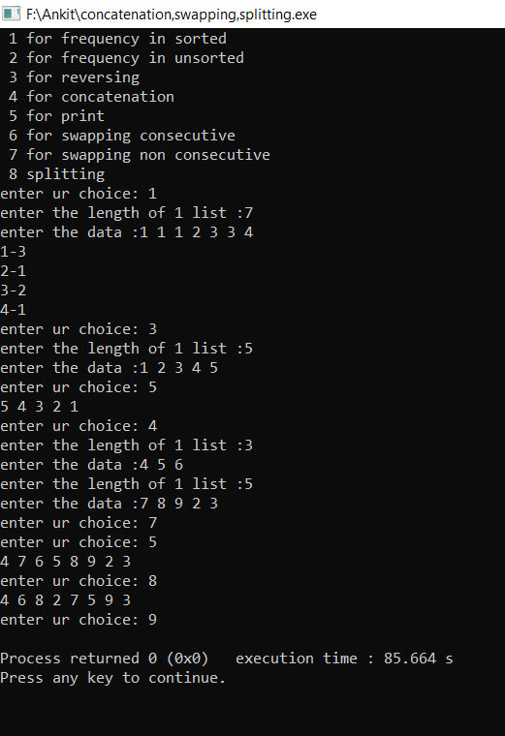

**6.1 Write a program to create doubly linked list which can store integers and write funcions to perform**

1. **Insertion in list**
2. **Deletion in list**
3. **Display of list in reverse direction**
4. **Display of list in forward direction**

#include<iostream>

using namespace std;

struct node

{

int data;

node *next,*prev;

};

class linklist

{

private:

node *head,*tail;

public:

linklist()

{

head=NULL;

tail=NULL;

}

void insertion(int j,int n) //insertion of nodes

{

int i;

if(head==NULL && tail==NULL)

{

head=new node;

tail=head;

head->data=n;

head->next=NULL;

head->prev=NULL;

//cout<<1;

}

else

{

node *temp=head;

for(i=1;i<j;i++)

{

if(temp->next==NULL)

{

break;

}

temp=temp->next;

}

if(temp->next!=NULL)

{

temp->next->prev=new node;

temp->next->prev->data=n;

temp->next->prev->prev=temp;

temp->next->prev->next=temp->next;

temp->next=temp->next->prev;

//cout<<23;

}

else

{

temp->next=new node;

temp->next->data=n;

temp->next->next=NULL;

temp->next->prev=temp;

tail=temp->next;

}

}

}

void del(int i) //deletion of nodes

{

node *temp=head;

if(i==1)

{

if(temp->next==NULL)

{

head=NULL;

tail=NULL;

delete temp;

}

else

{

temp->next->prev=NULL;

head=temp->next;

delete temp;

}

}

else

{

int j;

for(j=1;j<i;j++)

{

temp=temp->next;

}

if(temp->next==NULL)

{

temp->prev->next=NULL;

tail=temp->prev;

delete temp;

}

else

{

temp->prev->next=temp->next;

temp->next->prev=temp->prev;

delete temp;

}

}

}

void print()

{

cout<<"forward order :\n";

node *temp=head;

while(temp!=NULL)

{

cout<<temp->data<<" ";

temp=temp->next;

}

cout<<"\n";

}

void rev_print()

{

cout<<"reverse order :\n";

node *temp=tail;

while(temp!=NULL)

{

cout<<temp->data<<" ";

temp=temp->prev;

}

}

};

int main()

{

linklist l;

int i,n;

cout<<"enter the index after which u want to insert and data :";

cin>>i>>n;

l.insertion(i,n);

cin>>i>>n;

l.insertion(i,n);

cin>>i>>n;

l.insertion(i,n);

cin>>i>>n;

l.insertion(i,n);

l.del(1);

l.del(2);

l.print();

l.rev_print();

}

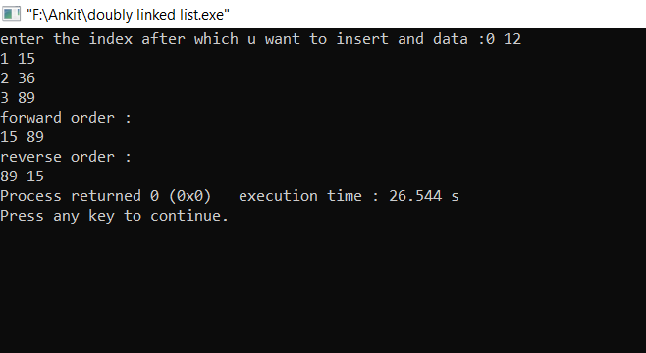

**6.2 (a) WAP to create polynomial using linked list and perform addition and multiplication .**

#include<iostream>

using namespace std;

struct node

{

int data,power;

node *next;

};

class linklist

{

private:

node *head=NULL;

public:

void insertion_end(int n,int x)

{

node *temp=head;

if(temp==NULL)

{

head=new node;

head->next=NULL;

head->data=n;

head->power=x;

}

else

{

while(temp->next!=NULL)

{

temp=temp->next;

}

temp->next=new node;

temp->next->next=NULL;

temp->next->data=n;

temp->next->power=x;

}

}

void print()

{

node *temp=head;

if(temp!=NULL)

{

while(temp!=NULL)

{

cout<<temp->data<<"x^"<<temp->power<<"+";

temp=temp->next;

}

}

}

node* return_head()

{

return head;

}

node** return_add()

{

return &head;

}

void sorted(node *list1,node *list2)

{

while(list1!=NULL || list2!=NULL)

{

if(list1!=NULL && list2!=NULL)

{

if(list1->power>list2->power)

{

insertion_end(list1->data,list1->power);

list1=list1->next;

}

else if(list1->power<list2->power)

{

insertion_end(list2->data,list2->power);

list2=list2->next;

}

else

{

insertion_end(list2->data+list1->data,list2->power);

list2=list2->next;

list1=list1->next;

}

}

else if(list1==NULL && list2!=NULL)

{

insertion_end(list2->data,list2->power);

list2=list2->next;

}

else if(list2 ==NULL && list1!=NULL)

{

insertion_end(list1->data,list1->power);

list1=list1->next;

}

}

}

};

int main()

{

linklist l1,l2,l3;

int i,n,x;

cout<<"enter polynomial :\n";

for(i=0;i<3;i++)

{ cin>>n>>x;

l1.insertion_end(n,x);

}

cout<<"enter polynomial :\n";

for(i=0;i<2;i++)

{

cin>>n>>x;

l2.insertion_end(n,x);

}

// l1.print();

l3.sorted(l1.return_head(),l2.return_head());

l3.print();

}

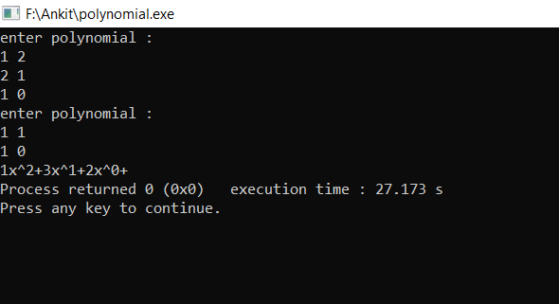

**6.2 (b) Write a program for polynomial multiplication.**

#include<iostream>

using namespace std;

struct node

{

int data,power;

node *next;

};

class linklist

{

private:

node *head=NULL;

public:

void insertion_end(int n,int x)

{

node *temp=head;

if(temp==NULL)

{

head=new node;

head->next=NULL;

head->data=n;

head->power=x;

}

else

{

while(temp->next!=NULL)

{

temp=temp->next;

}

temp->next=new node;

temp->next->next=NULL;

temp->next->data=n;

temp->next->power=x;

}

}

void print()

{

node *temp=head;

if(temp!=NULL)

{

while(temp!=NULL)

{

cout<<temp->data<<"x^"<<temp->power<<"+";

temp=temp->next;

}

}

}

node* return_head()

{

return head;

}

node** return_add()

{

return &head;

}

void sorted(node *list1,node *list2)

{

node *temp1=list1,*temp2;

while(temp1!=NULL)

{

temp2=list2;

while(temp2!=NULL)

{

insertion_end((temp1->data)*(temp2->data),(temp1->power)+(temp2->power));

temp2=temp2->next;

}

temp1=temp1->next;

}

}

void mul(node *l3)

{

int sum=0;

while(l3!=NULL)

{

sum=l3->data;

node *temp=l3->next,*temp1=l3;

while(temp!=NULL)

{

if(l3->power==temp->power)

{

sum=sum+temp->data;

temp1->next=temp->next;

temp=temp->next;

}

else

{

temp=temp->next;

temp1=temp1->next;

}

}

insertion_end(sum,l3->power);

l3=l3->next;

}

}

};

int main()

{

linklist l1,l2,l3,l4;

int i,n,x;

for(i=0;i<3;i++)

{ cin>>n>>x;

l1.insertion_end(n,x);

}

for(i=0;i<3;i++)

{

cin>>n>>x;

l2.insertion_end(n,x);

}

// l1.print();

l3.sorted(l1.return_head(),l2.return_head());

//l3.print();

l4.mul(l3.return_head());

l4.print()

}

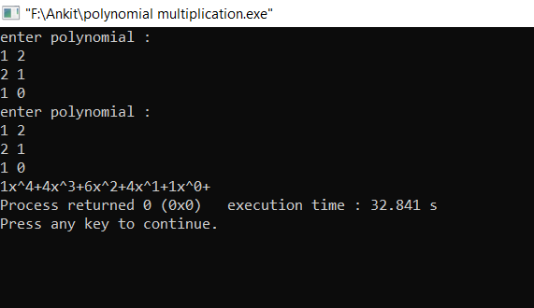

**7.1 WAP a program to implement operations of stack .**

#include<iostream>

#include<stdlib.h>

using namespace std;

struct arraystack

{

int top,cap,base;

long long int *no;

};

arraystack* create(int n)

{

arraystack *head=(arraystack*)malloc(sizeof(arraystack));

head->top=-1;

head->cap=n;

head->base=0;

head->no=(long long int*)malloc(sizeof(long long int)*n);

return head;

}

int full(arraystack *head)

{

if(head->top==(head->cap)-1)

return 1;

return 0;

}

int blank(arraystack *head)

{

if(head->top==-1)

return 1;

return 0;

}

void push(arraystack *head,long long int n)

{

if(!full(head))

{

head->top++;

head->no[head->top]=n;

}

}

long long int pop(arraystack *head)

{

int n;

if(head->top!=-1)

{

n=head->no[head->top];

head->top--;

return n;

}

}

int main()

{

long long int n,k,i,x,greatest =0;

cout<<"enter capacity of stack :\n";

cin>>n;

cout<<"enter elements\n";

arraystack *Stack=create(n),*Stack1=create(n);

for(i=0;i<n;i++)

{

cin>>x;

push(Stack,x);

}

for(i=0;i<2;i++)

{

cout<<"popped element is :"<<pop(Stack)<<"\n";

}

}

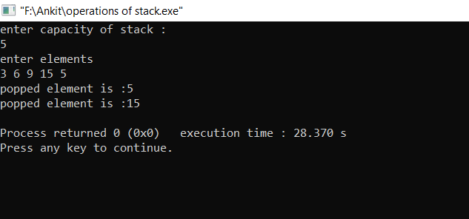

**7.2 (a) Write a program to convert Infix expression to postfix expression.**

#include<iostream>

using namespace std;

struct stack1

{

int top,size1;

char *ptr;

};

stack1* create_stack(int k)

{

stack1 *n;

n=new stack1;

n->top=-1;

n->size1=k;

n->ptr=new char[k];

return n;

}

void push(char k,stack1 *n)

{

n->top++;

n->ptr[n->top]=k;

}

char pop(stack1 *n)

{

n->top--;

return n->ptr[n->top+1];

}

int main()

{

stack1 *s;

char a[100],b[100]={'\0'},c;

s=create_stack(100);

cout<<"Enter infix string\n";

cin>>a;

int i=0,j=0;

while(a[i]!='\0')

i++;

a[i]=')';

push('(',s);

i=0;

j=0;

while(s->top!=-1)

{

if(a[i]>=48&&a[i]<=57)

{

b[j]=a[i];

j++;

}

else if(a[i]!='('&&a[i]!=')')

{

if(a[i]=='^')

push('^',s);

else if(a[i]=='/'||a[i]=='*')

{

abc: c=pop(s);

if(c=='^')

{

b[j]=c;

j++;

goto abc;

}

else

push(c,s);

push(a[i],s);

}

else if(a[i]=='+'||a[i]=='-')

{

bcd: c=pop(s);

if(c=='^'||c=='*'||c=='/')

{

b[j]=c;

j++;

goto bcd;

}

else

push(c,s);

push(a[i],s);

}

}

else if(a[i]=='(')

push(a[i],s);

else if(a[i]==')')

{

while(1)

{

c=pop(s);

if(c=='(')

break;

else

{

b[j]=c;

j++;

}

}

}

i++;

}

cout<<b<<"\n";

}

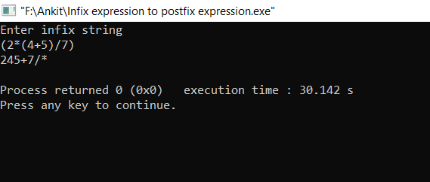

**7.2 (b)Write a program to evaluate postfix expression.**

#include<iostream>

#include<malloc.h>

#include<stdio.h>

using namespace std;

struct arrstack

{

int top;

unsigned cap;

int *ptr;

};

arrstack *temp;

void create_stack()

{

temp=(arrstack *)malloc(sizeof(arrstack*));

temp->top=0;

temp->cap=20;

temp->ptr=(int *)malloc(sizeof(int)*temp->cap);

}

void push(int x)

{

temp->ptr[temp->top]=x;

temp->top++;

}

int pop()

{

int t;

t=temp->ptr[temp->top-1];

temp->top--;

return t;

}

main()

{

int i=0,x,y,value,t;

create_stack();

char s[50];

cout<<"enter a string\n";

gets(s);

for(i=0;s[i]!='\0';i++)

{

if(s[i]>=48&&s[i]<=57)

{

t=0;

while(s[i]!=',')

{

t=(t*10)+s[i]-48;

i++;

}

push(t);

}

else if(s[i]=='*')

{

x=pop();

y=pop();

t=y*x;

push(t);

}

else if(s[i]=='+')

{

x=pop();

y=pop();

t=y+x;

push(t);

}

else if(s[i]=='-')

{

x=pop();

y=pop();

t=y-x;

push(t);

}

else if(s[i]=='/')

{

x=pop();

y=pop();

t=y/x;

push(t);

}

}

value=pop();

cout<<value;

}

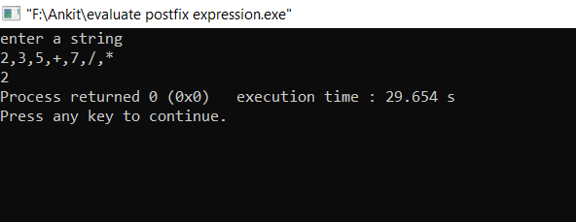

**7.3 Write a program to convert decimal to octal using stack.**

#include<iostream>

#include<stdlib.h>

using namespace std;

struct arraystack

{

int top,cap;

long long int *no;

};

arraystack* create(int n)

{

arraystack *head=(arraystack*)malloc(sizeof(arraystack));

head->top=-1;

head->cap=n;

// head->base=0;

head->no=(long long int*)malloc(sizeof(long long int)*n);

return head;

}

int full(arraystack *head)

{

if(head->top==(head->cap)-1)

return 1;

return 0;

}

int blank(arraystack *head)

{

if(head->top==-1)

return 1;

return 0;

}

void push(arraystack *head,long long int n)

{

if(!full(head))

{

head->top++;

head->no[head->top]=n;

}

}

long long int pop(arraystack *head)

{

int n;

if(!blank(head))

{

n=head->no[head->top];

head->top--;

return n;

}

}

void print(arraystack *head)

{

while(!blank(head))

{

cout<<pop(head);

}

}

int main()

{

arraystack *s=create(100);

long long int n;

cout<<"enter the decimal form :\n";

cin>>n;

while(n>0)

{

push(s,n%8);

n=n/8;

}

print(s);

}

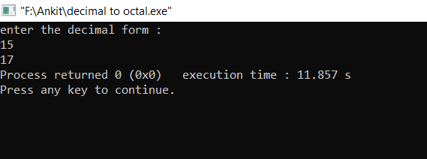

**8.1 Write a program to sort elements using quick sort using Stack.**

#include<iostream>

using namespace std;

struct stack1

{

int top,size1;

int *ptr;

};

stack1* create_stack(int k)

{

stack1 *n;

n=new stack1;

n->top=-1;

n->size1=k;

n->ptr=new int[k];

return n;

}

int isfull(stack1 *n)

{

if(n->top==n->size1-1)

return 1;

else

return 0;

}

int isempty(stack1 *n)

{

if(n->top==-1)

return 1;

else

return 0;

}

void push(int k,stack1 *n)

{

if(!isfull(n))

{

n->top++;

n->ptr[n->top]=k;

}

}

int pop(stack1 *n)

{

if(!isempty(n))

{

n->top--;

return n->ptr[n->top+1];

}

}

inline void swap1(int &a,int &b)

{

int c;

c=a;

a=b;

b=c;

}

void display(stack1 *n)

{

int a,b=0;

a=n->top;

while(b!=a+1)

{

cout<<n->ptr[b]<<" ";

b++;

}

cout<<"\n";

}

int main()

{

int n,j=0;

stack1 *low,*up;

low=create_stack(100);

up=create_stack(100);

cout<<"enter number of elements\n";

cin>>n;

int a[n];

cout<<"enter values\n";

while(j!=n)

{

cin>>a[j];

j++;

}

push(0,low);

push(n-1,up);

int beg,en,left,right,loc,k;

while(low->top!=-1)

{

left=beg=pop(low);

right=en=pop(up);

loc=beg;

j=1;

k=1;

while(j)

{

switch(k)

{

case 1:

while(a[loc]<=a[right]&&loc!=right)

{

right--;

}

if(loc==right)

{

j=0;

break;

}

if(a[right]<a[loc])

{

swap1(a[loc],a[right]);

loc=right;

k=2;

}

break;

case 2:

while(a[loc]>=a[left]&&loc!=left)

{

left++;

}

if(loc==left)

{

j=0;

break;

}

if(a[left]>a[loc])

{

swap1(a[loc],a[left]);

loc=left;

k=1;

}

break;

}

}

if(beg<loc-1)

{

push(beg,low);

push(loc-1,up);

}

if(loc+1<en)

{

push(loc+1,low);

push(en,up);

}

}

j=0;

while(j!=n)

{

cout<<a[j]<<" ";

j++;

}

cout<<"\n";

}

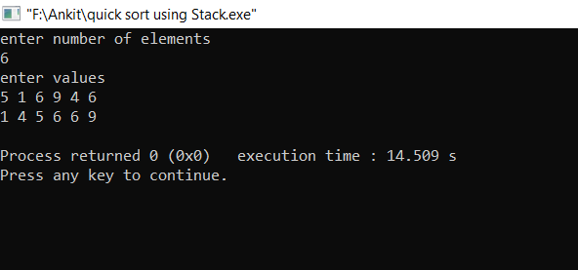

**8.2(a) Write a program to find GCD of numbers using recursion.**

#include<iostream>

using namespace std;

int gcd(int a,int b)

{

if(a>=b)

{

if(a%b==0)

return b;

else

return gcd(b,a%b);

}

else

{

if(b%a==0)

return a;

else

return gcd(a,b%a);

}

}

int main()

{

cout<<"enter two no.\n";

int a,b;

cin>>a>>b;

cout<<gcd(a,b);

}

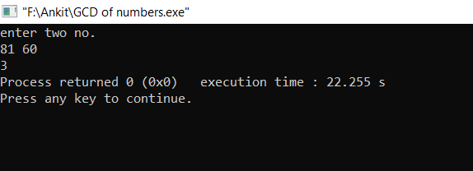

**8.2(b) Write a program to apply quick sort using recursion.**

#include<iostream>

using namespace std;

void quick_sort(int a[],int first, int last)

{

int low=first,high=last,pivot,temp;

pivot=a[(low+high)/2];

while(low<=high)

{

while(a[low]<pivot)

low++;

while(a[high]>pivot)

high--;

if(low<=high)

{

temp=a[low];

a[low]=a[high];

a[high]=temp;

low++;

high--;

}

}

if(first<high)

quick_sort(a,first,high);

if(low<last)

quick_sort(a,low,last);

}

int main()

{

int n;

cout<<"enter no of elements :";

cin>>n;

cout<<"enter elements :\n";

int a[n],i;

for(i=0;i<n;i++)

cin>>a[i];

quick_sort(a,0,n-1);

for(i=0;i<n;i++)

cout<<a[i]<<" ";

}

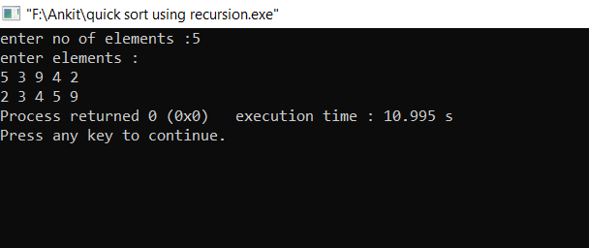

**8.2(c1) Write a program to calculate factorial of a number using non tail recursion.**

#include<iostream>

using namespace std;

int factl(int n)

{

if(n==0)

return 1;

else

return n*fact(n-1);

}

int main()

{

int n;

cout<<"enter the no. u want to calculate factorial :\n";

cin>>n;

cout<<fact(n);

}

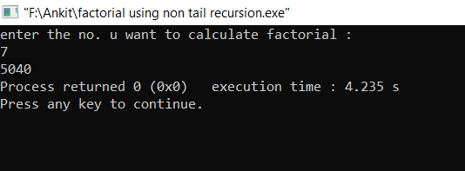

**8.2 (c2) Write a program to calculate factorial using tail recursion.**

#include<iostream>

using namespace std;

int fact(int n,int ans=1)

{

if(n==0)

return ans;

else

{

ans=n*ans;

return fact(n-1,ans);

}

}

int main()

{

int n;

cout<<"enter the no. u want to calculate factorial :\n";

cin>>n;

cout<<fact(n);

}

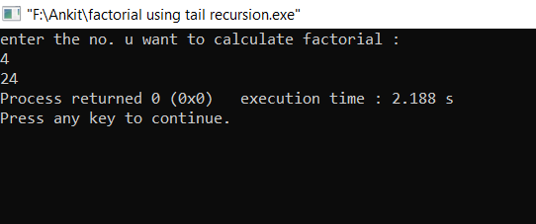

**8.2(d1) Write a program to print fibonnaci series using non tail recusrion.**

#include<iostream>

using namespace std;

int fibo(int n)

{

if(n==1)

return 0;

else if(n==2)

return 1;

else

return fibo(n-1)+fibo(n-2);

}

void series(int n)

{

int i;

cout<<"series is as follows :\n";

for(i=1;i<=n;i++)

cout<<fibo(i)<<" ";

}

int main()

{

cout<<"enter the no of terms u want to print :\n";

int n;

cin>>n;

series(n);

}

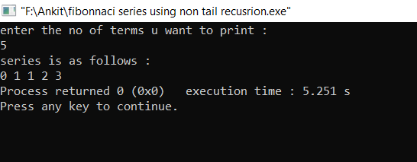

**8.2(d2) Write a program to print fibonnaci series using tail recursion.**

#include<iostream>

using namespace std;

int fibo(int n,int f1=0,int f2=1)

{

if(n==0)

return f1;

else if(n==1)

return f2;

else

{

return fibo(n-1,f2,f2+f1);

}

}

void series(int n)

{

int i;

cout<<"series is as follows :\n";

for(i=1;i<=n;i++)

cout<<fibo(i)<<" ";

}

int main()

{

cout<<"enter the no of terms u want to print :\n";

int n;

cin>>n;

series(n);

}

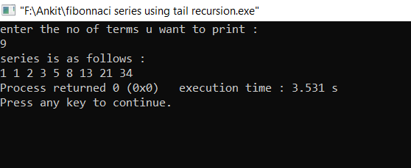

**9.1 WAP to implement basic operations on queue using array(Insertion,Deletion and display of elements).**

#include<iostream>

#include<stdlib.h>

using namespace std;

struct arrayqueue

{

int top,base,cap;

int *no;

};

arrayqueue* create(int n)

{

arrayqueue *temp=(arrayqueue*)malloc(sizeof(arrayqueue));

temp->top=-1;

temp->base=-1;

temp->cap=n;

temp->no=(int*)malloc(sizeof(int)*n);

return temp;

}

int full(arrayqueue *head)

{

if((head->top+1)%(head->cap)==(head->base))

return 1;

else

return 0;

}

int blank(arrayqueue *head)

{

if(head->top == -1 && head->base==-1)

return 1;

else

return 0;

}

void enqueue(arrayqueue *head,int n)

{

if(!full(head))

{

head->top=((head->top)+1)%(head->cap);

head->no[head->top]=n;

if(head->base==-1)

head->base=head->top;

}

}

int dequeue(arrayqueue *head)

{

if(!blank(head))

{

int n=head->no[head->base];

if(head->base==head->top)

{

head->base=head->top=-1;

}

else

head->base =((head->base)+1)%(head->cap);

return n;

}

}

void reversequeue(arrayqueue *head)

{

int temp=0;

if(!blank(head))

{

temp=dequeue(head);

if(!blank(head))

reversequeue(head);

}

enqueue(head,temp);

}

void print(arrayqueue *head)

{

while(!blank(head))

{

cout<<dequeue(head)<<" ";

}

}

int main()

{

int i,n;

cout<<"enter the capacity :";

cin>>n;

arrayqueue *q=create(n);

cout<<"enter numbers:\n";

for(i=0;i<n;i++)

{

int x;

cin>>x;

enqueue(q,x);

}

cout<<"enter the no. of elements u want to delete :";

cin>>n;

while(n--)

dequeue(q);

cout<<"final list :\n";

print(q);

}

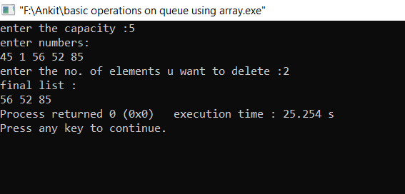

**9.2 WAP to implement basic operations on queue using linked list**.

#include<iostream>

#include<stdlib.h>

using namespace std;

struct node

{

int data;

struct node *next;

};

void enqueue(node **head,int n)

{

node *new1=(node*)malloc(sizeof(node)),*temp=*head;

new1->next=NULL;

new1->data=n;

if(*head==NULL)

{

*head=new1;

}

else

{

while(temp->next!=NULL)

temp=temp->next;

temp->next=new1;

}

}

int dequeue(node** head)

{

int no;

node *temp=*head;

if(temp==NULL)

{

cout<<"stack is empty\n";

return -1;

}

else

{

no=temp->data;

*head=temp->next;

delete(temp);

return no;

}

}

void print(node *head)

{

while(head!=NULL)

{

cout<<head->data<<"\n";

head=head->next;

}

}

int main()

{

node *head=(node*)malloc(sizeof(node));

head->next=NULL;

int n;

cout<<"enter the data of head\n";

cin>>head->data;

while(1)

{

cout<<"enter ur choice 1 enqueue \n 2 dequeue\n3 print \n4 exit\n";

int ch;

cin>>ch;

switch(ch)

{

case 1:

cout<<"enter data\n";

cin>>n;

enqueue(&head,n);

break;

case 2:

n=dequeue(&head);

cout<<n;

break;

case 3:

print(head);

break;

case 4:

exit(0);

break;

}

}

}

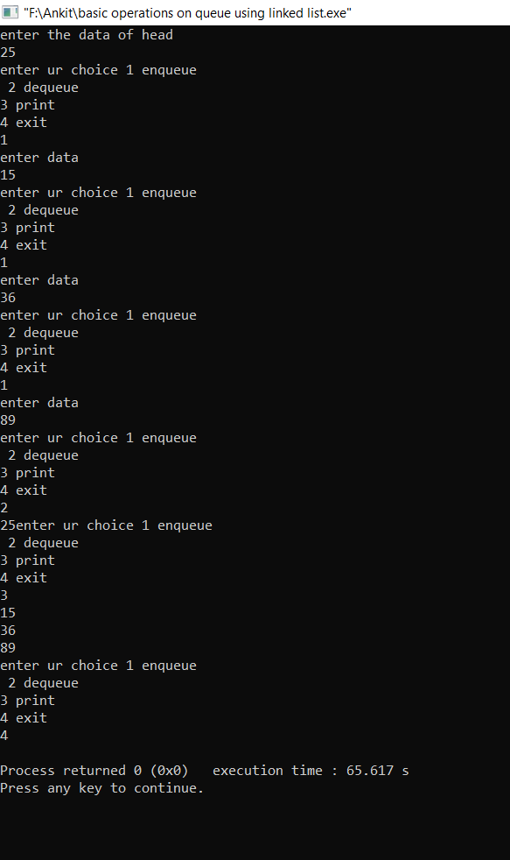

**9.3(a) WAP to implement Input restricted Queue.**

#include<bits/stdc++.h>

using namespace std;

class queue1

{

int cap,top,base,*no;

public:

void create(int n)

{

cap=n;

top=-1;

base=-1;

no=new int[n];

}

bool full()

{

if(((top+1)%cap)==base)

return 1;

else

return 0;

}

bool blank()

{

if((top==-1)&&base ==-1)

return 1;

else

return 0;

}

void enqueue(int n)

{

if(!full())

{

top=(top+1)%cap;

no[top]=n;

if(base==-1)

base=top;

}

}

int dequeue(int k=0)

{

int n;

if(k==0)

{

if(!blank())

{

n=no[base];

if(base==top)

base=top=-1;

else

base=(base+1)%cap;

return n;

}

}

else if(k==1)

{

if(!blank())

{

n=no[top];

if(base==top)

base=top=-1;

else

top=(top+cap-1)%cap;

return n;

}

}

return -1;

}

void print()

{

while(!blank())

{

cout<<dequeue()<<" ";

}

}

};

int main()

{

queue1 q;

cout<<"enter the capacity of queue :";

int n;

cin>>n;

q.create(n);

cout<<"enter your choice :\n1 enqueue\n2 dequeue\n3 exit";

while(1)

{

int ch,x;

cin>>ch;

switch(ch)

{

case 1:

cout<<"enter data :";

cin>>x;

q.enqueue(x);

break;

case 2:

cout<<"press 0 to dequeue from base and 1 from top: ";

int k;

cin>>k;

cout<<q.dequeue(k);

break;

case 3:

exit(0);

}

}

}

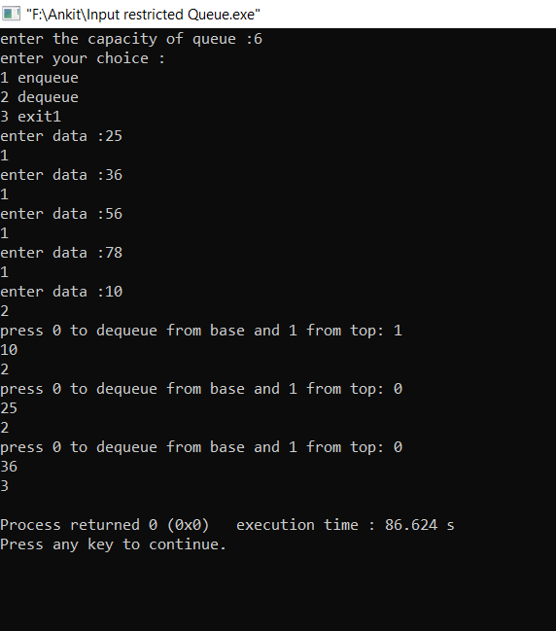

**9.3(b) Write a program to implement output restricted queue.**

#include<bits/stdc++.h>

using namespace std;

class queue1

{

int cap,top,base,*no;

public:

void create(int n)

{

cap=n;

top=-1;

base=-1;

no=new int[n];

}

bool full()

{

if(((top+1)%cap)==base)

return 1;

else

return 0;

}

bool blank()

{

if((top==-1)&&base ==-1)

return 1;

else

return 0;

}

void enqueue(int k,int n)

{

if(k==0)

{

if(!full())

{

top=(top+1)%cap;

no[top]=n;

if(base==-1)

base=top;

}

}

else if(k==1)

{

if(!full())

{

base=(base+cap-1)%cap;

no[base]=n;

if(top==-1)

top=base;

}

}

}

int dequeue()

{

int n;

if(!blank())

{

n=no[base];

if(base==top)

base=top=-1;

else

base=(base+1)%cap;

return n;

}

return -1;

}

void print()

{

while(!blank())

{

cout<<dequeue()<<" ";

}

}

};

int main()

{

queue1 q;

cout<<"enter the capacity of queue :";

int n;

cin>>n;

q.create(n);

cout<<"enter your choice :\n1 enqueue\n2 dequeue\n3 exit";

while(1)

{

int ch,x;

cin>>ch;

switch(ch)

{

case 1:

cout<<"enter data :";

cin>>x;

cout<<"press 0 to enqueue from top and 1 from base ";

int k;

cin>>k;

q.enqueue(k,x);

break;

case 2:

cout<<q.dequeue();

break;

case 3:

exit(0);

}

}

}

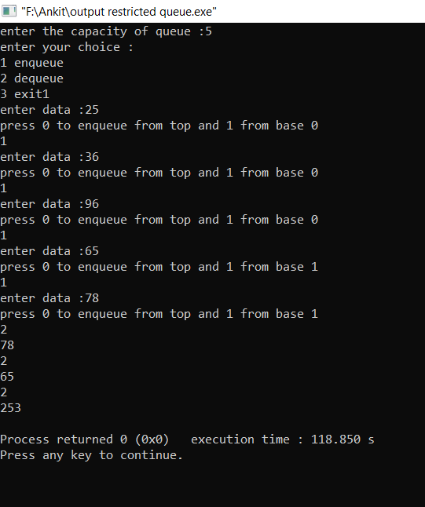

**9.4(a) WAP to implement Priority queue using linked list.**

#include <iostream>

#include <stdlib.h>

using namespace std;

struct Node {

int data;

int priority;

Node* next;

};

Node* newNode(int d, int p)

{

Node* temp = (Node*)malloc(sizeof(Node));

temp->data = d;

temp->priority = p;

temp->next = NULL;

return temp;

}

int peek(Node** head)

{

return (*head)->data;

}

void pop(Node** head)

{

Node* temp = *head;

(*head) = (*head)->next;

free(temp);

}

void push(Node** head, int d, int p)

{

Node* start = (*head);

Node* temp = newNode(d, p);

if ((*head)->priority > p) {

temp->next = *head;

(*head) = temp;

}

else {

while (start->next != NULL &&

start->next->priority < p) {

start = start->next;

}

temp->next = start->next;

start->next = temp;

}

}

int isEmpty(Node** head)

{

return (*head) == NULL;

}

int main()

{

cout<<"enter no of elements:";

int n;

cin>>n;

cout<<"enter data and priority :";

int x,y,i;

cin>>x>>y;

Node* pq = newNode(x,y);

for(i=0;i<n-1;i++)

{

cin>>x>>y;

push(&pq,x,y);

}

while (!isEmpty(&pq)) {

cout<<peek(&pq)<<" ";

pop(&pq);

}

return 0;

}

#include <iostream>

#include <stdlib.h>

using namespace std;

struct Node {

int data;

int priority;

Node* next;

};

Node* newNode(int d, int p)

{

Node* temp = (Node*)malloc(sizeof(Node));

temp->data = d;

temp->priority = p;

temp->next = NULL;

return temp;

}

int peek(Node** head)

{

return (*head)->data;

}

void pop(Node** head)

{

Node* temp = *head;

(*head) = (*head)->next;

free(temp);

}

void push(Node** head, int d, int p)

{

Node* start = (*head);

Node* temp = newNode(d, p);

if ((*head)->priority > p) {

temp->next = *head;

(*head) = temp;

}

else {

while (start->next != NULL &&

start->next->priority < p) {

start = start->next;

}

temp->next = start->next;

start->next = temp;

}

}

int isEmpty(Node** head)

{

return (*head) == NULL;

}

int main()

{

cout<<"enter no of elements:";

int n;

cin>>n;

cout<<"enter data and priority :";

int x,y,i;

cin>>x>>y;

Node* pq = newNode(x,y);

for(i=0;i<n-1;i++)

{

cin>>x>>y;

push(&pq,x,y);

}

while (!isEmpty(&pq)) {

cout<<peek(&pq)<<" ";

pop(&pq);

}

return 0;

}

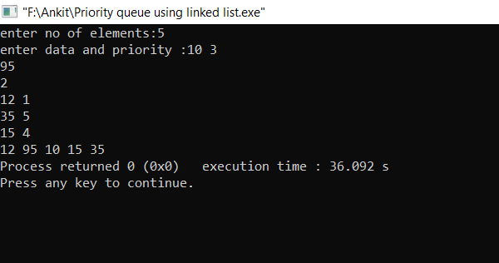

**9.4(b) Write a program to implement priority queue by array.**

#include<bits/stdc++.h>

using namespace std;

struct arrayqueue

{

int top,base,cap;

int *no;

};

arrayqueue* create(int n)

{

arrayqueue *temp=(arrayqueue*)malloc(sizeof(arrayqueue));

temp->top=-1;

temp->base=-1;

temp->cap=n;

temp->no=(int*)malloc(sizeof(int)*n);

return temp;

}

int full(arrayqueue *head)

{

if((head->top+1)%(head->cap)==(head->base))

return 1;

else

return 0;

}

int blank(arrayqueue *head)

{

if(head->top == -1 && head->base==-1)

return 1;

else

return 0;

}

void enqueue(arrayqueue *head,int n)

{

if(!full(head))

{

head->top=((head->top)+1)%(head->cap);

head->no[head->top]=n;

if(head->base==-1)

head->base=head->top;

}

}

int dequeue(arrayqueue *head)

{

if(!blank(head))

{

int n=head->no[head->base];

if(head->base==head->top)

{

head->base=head->top=-1;

}

else

head->base =((head->base)+1)%(head->cap);

return n;

}

else return -1;

}

int main()

{

int n,i,j=1;

cout<<"enter the no. of priorities :\n";

cin>>n;

arrayqueue *q[n];

i=0;

while(i<n)

{

q[i]=create(10);

i++;

}

while(1)

{

cout<<"1 to insert\n 2 to delete\n3 to display";

cout<<"\nenter your choice\n";

cin>>j;

switch(j)

{

case 1:

cout<<"enter the priority of element u want to :\n";

int x;

cin>>x;

cout<<"enter the element :\n";

int y;

cin>>y;

enqueue(q[x-1],y);

break;

case 2:

y=0;

while(1 && y<n)

{

if(blank(q[y]))

y++;

if(dequeue(q[y]))

break;

}

break;

case 3:

y=0;

while(1 && y<n)

{

if(blank(q[y]))

y++;

else

cout<<dequeue(q[y])<<" ";

}

break;

}

}

}

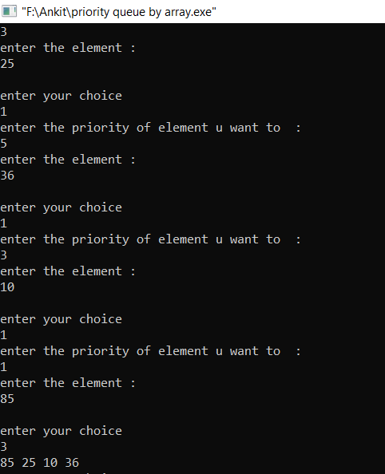

**10.1 WAP to implement the basic operations on Binary tree**

1. **Insertion**
2. **Deletion**
3. **Counting Number of nodes**
4. **Height of tree**

#include<iostream>

using namespace std;

struct node

{

int info;

node *left,*right;

};

node* create_node(int a)

{

node *n;

n=new node;

n->info=a;

n->left='\0';

n->right='\0';

return n;

}

void set_node(int a,node *p,node *r,char c)

{

int k=0;

if(a==r->info)

{

k=1;

if(c=='l')

r->left=p;

else

r->right=p;

}

if(k==0)

{

if(r->left!='\0')

set_node(a,p,r->left,c);

if(r->right!='\0')

set_node(a,p,r->right,c);

}

}

void display(node *r)

{

cout<<r->info<<" ";

if(r->left!='\0')

display(r->left);

if(r->right!='\0')

display(r->right);

}

node *x='\0';

void find_node(int a,node *r)

{

if(r->left->info==a||r->right->info==a)

x=r;

else

{

if(r->left!='\0')

find_node(a,r->left);

if(r->right!='\0')

find_node(a,r->right);

}

}

void delete_node(int a,node *r)

{

node *n,*p;

int k=1;

find_node(a,r);

cout<<"hello\n";

n=x;

p=n->left;

if(p->info!=a)

{

p=n->right;

k=2;

}

cout<<n->info<<" "<<p->info<<" ";

if(p->left=='\0'&&p->right=='\0')

{

delete p;

if(k==1)

n->left='\0';

else

n->right='\0';

}

else if(p->left=='\0')

{

if(k==1)

n->left=p->right;

else

n->right=p->right;

delete p;

}

else if(p->right=='\0')

{

if(k==1)

n->left=p->left;

else

n->right=p->left;

delete p;

}

}

int maximum(int a,int b)

{

if(a>=b)

return a;

else

return b;

}

int height(node *r)

{

if(r=='\0')

return 0;

else

return (1+maximum(height(r->left),height(r->right)));

}

int main()

{

node *root,*p;

int n,a,b,i,j,k;

char c;

cout<<"press 1 for create a tree\npress 2 for insert a node\npress 3 for preorder display\n";

cout<<"press 4 for delete a node\npress 5 for find height of tree\npress 6 for exit\n";

cout<<"enter choice\n";

cin>>j;

while(j!=6)

{

switch(j)

{

case 1:

cout<<"enter total number of nodes\n";

cin>>n;

cout<<"enter root node\n";

cin>>a;

root=create_node(a);

k=n;

k=k-1;

while(k--)

{

cout<<"enter parent node,node info and side(l or r)\n";

cin>>a>>b>>c;

p=create_node(b);

set_node(a,p,root,c);

}

break;

case 2:

cout<<"enter parent node,node info and side(l or r)\n";

cin>>a>>b>>c;

p=create_node(b);

set_node(a,p,root,c);

break;

case 3:

display(root);

cout<<"\n";

break;

case 4:

cout<<"enter node info\n";

cin>>a;

delete_node(a,root);

break;

case 5:

a=height(root);

cout<<"height of the tree is "<<a<<"\n";

break;

}

cout<<"enter choice\n";

cin>>j;

}

}

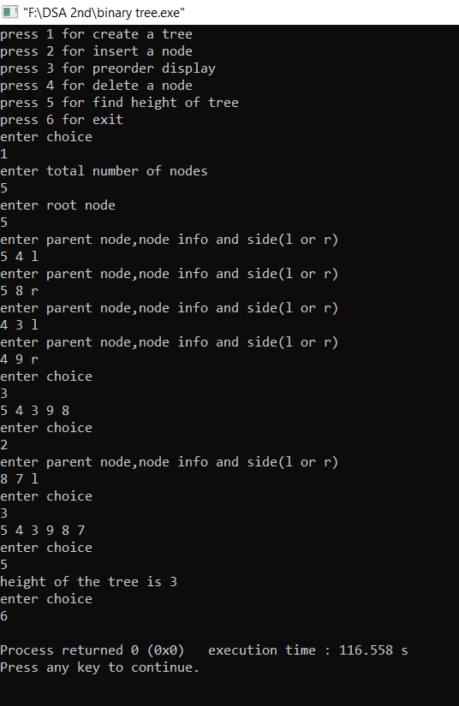

**10.2 WAP to implement the basic operations on Binary Search tree**

1. **Insertion**
2. **Deletion**
3. **Counting Number of Nodes**
4. **Height of tree**

#include<iostream>

using namespace std;

struct node

{

int num;

node*l,*r;

};

node*f(int);

void inorder(node*);

int height(node*);

node* insert1(node*,int);

node* delete1(node*,int);

int main()

{

node*root=0;

int e;

root=f(4);

root->l=f(2);

root->r=f(5);

root->l->l=f(1);

root->l->r=f(3);

cout<<"inorder ";

inorder(root);

cout<<"\nheight="<<height(root)<<"\n";

cout<<"enter item to insert";

cin>>e;

root=insert1(root,e);

inorder(root);

cout<<"enter the item to delete";

cin>>e;

root=delete1(root,e);

inorder(root);

return 0;

}

node*f(int a)

{

node*n=new node;

n->num=a;

n->l=0;

n->r=0;

return n;

}

void inorder(node*p)

{

if(p==0)

return;

inorder(p->l);

cout<<p->num<<" ";

inorder(p->r);

}

int height(node*p)

{

if(p==0)

return 0;

return 1+max(height(p->l),height(p->r));

}

node* insert1(node*p,int a)

{

if(p==0)

return f(a);

else if(a>p->num)

p->r=insert1(p->r,a);

else

p->l=insert1(p->l,a);

}

node* delete1(node*p,int a)

{

if(p==0)

return p;

else if(a>p->num)

p->r=delete1(p->r,a);

else if(a<p->num)

p->l=delete1(p->l,a);

else

{

if(p->l!=0&&p->r!=0)

{

node*c=p->r;

while(c->l!=0)

c=c->l;

p->num=c->num;

p->r=delete1(p->r,c->num);

}

else if(p->l!=0)

p=p->l;

else

p=p->r;

}

return p;}

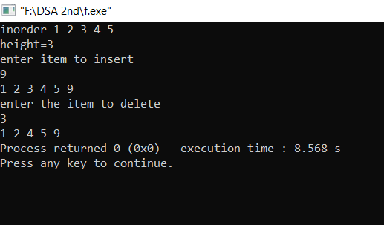

1. **WAP to implement:**
2. **Insertion in AVL tree**
3. **In-order Traversal of AVL tree**
4. **Balance Factor of AVL Tree**

#include<bits/stdc++.h>

using namespace std;

struct avlnode

{

int data;

avlnode *left,*right;

};

int height(avlnode *head)

{

if(head==NULL)

return 0;

else

return(1+max(height(head->left),height(head->right)));

}

int balance_factor(avlnode *head)

{

return (height(head->left)-height(head->right));

}

avlnode* llRotation(avlnode *head)

{

avlnode *temp=head->left;

head->left=temp->right;

temp->right=head;

return temp;

}

avlnode* rrRotation(avlnode *head)

{

avlnode *temp=head->right;

head->right=temp->left;

temp->left=head;

return temp;

}

avlnode* lrRotation(avlnode *head)

{

head->left=rrRotation(head->left);

return llRotation(head);

}

avlnode* rlRotation(avlnode *head)

{

head->right=llRotation(head->right);

return rrRotation(head);

}

avlnode* insertion(avlnode *head,int n)

{

if(!head)

{

head=new avlnode;

head->data=n;

head->left=NULL;

head->right=NULL;

}

else if(n<head->data)

{

head->left=insertion(head->left,n);

if(height(head->left)-height(head->right)==2)

if(n<head->left->data)

head=llRotation(head);

else

head=lrRotation(head);

}

else if(n>head->data)

{

head->right=insertion(head->right,n);

if(height(head->left)-height(head->right)==-2)

if(n>head->right->data)

head=rrRotation(head);

else

head=rlRotation(head);

}

return head;

}

void inorder(avlnode *head)

{

if(head)

{

inorder(head->left);

cout<<head->data<<" ";

inorder(head->right);

}

}

int main()

{

int n;

cout<<"enter the no of elements :";

cin>>n;

avlnode *head=NULL;

cout<<"enter data :";

while(n--)

{

int x;

cin>>x;

head=insertion(head,x);

}

cout<<"inorder of avl tree is: \n";

inorder(head);

}

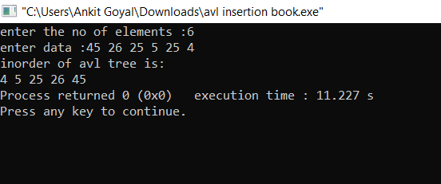

**12.1 WAP to implement operations:**

1. **Insertion in Heap Tree**
2. **Deletion in Heap tree**
3. **Deletion of Root Node from Heap**
4. **Sort the heap**

#include<bits/stdc++.h>

using namespace std;

void heapisation(int *no,int n,int i)

{

if(i>=1 && i<n)

{

if(no[i]>no[(i-1)/2])

{

int temp=no[i];

no[i]=no[(i-1)/2];

no[(i-1)/2]=temp;

i=(i-1)/2;

heapisation(no,n,i);

}

}

}

int deletion(int *no,int *n,int i)

{

int x=no[i],temp;

no[i]=no[*n];

if(2*i+2<*n)

{

if(no[i]<no[2*i+1] || no[i]<no[2*i+2])

{

temp=no[i];

no[i]=max(no[2*i+1],no[2*i+2]);

if(no[i]==no[2*i+1])

{

no[2*i+1]=temp;

i=2*i+1;

}

else

{

no[2*i+2]=temp;

i=2*i+2;

}

deletion(no,n,i);

}

}

else if(2*i+1<*n)

{

if(no[i]<no[2*i+1])

{

temp=no[i];

no[i]=(no[2*i+1]);

no[2*i+1]=temp;

i=2*i+1;

deletion(no,n,i);

}

}

return x;

}

void print(int *no,int n)

{

int i;

for(i=0;i<n;i++)

cout<<no[i]<<" ";

cout<<"\n";

}

int main()

{

int no[100],n,i,x;

cout<<"enter no. of elements :";

cin>>n;

x=n;

for(i=0;i<n;i++)

{

cin>>no[i];

heapisation(no,n,i);

}

cout<<"sorted array is :\n";

for(i=0;i<x;i++)

{

n=n-1;

cout<<deletion(no,&n,0)<<" ";

}

}

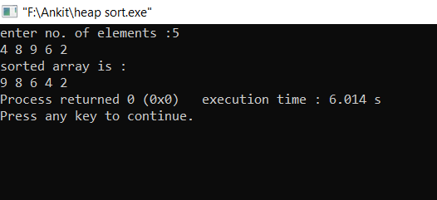

**12.2 WAP to implement:**

1. **Creation of Graph**
2. **Insertion of an edge**
3. **Deletion of an edge**
4. **Display of graph**

#include<bits/stdc++.h>

using namespace std;

struct graph

{

int v,e;

int **adj;

};

graph* create_graph()

{

int i,j,x,y;

graph *G;

G=new graph;

cout<<"enter no. of nodes and edges: ";

cin>>G->v>>G->e;

G->adj=(int**)malloc(sizeof(int*)*G->v);

for(i=0;i<G->v;i++)

G->adj[i]=(int*)malloc(sizeof(int)*G->v);

for(i=0;i<G->v;i++)

for(j=0;j<G->v;j++)

G->adj[i][j]=0;

cout<<"enter starting node and ending node for all edge: ";

for(i=0;i<G->e;i++)

{

cin>>x>>y;

G->adj[x][y]=1;

G->adj[y][x]=1;

}

return G;

}

main()

{

int ch;

graph *G;

G=create_graph();

while(1)

{

cout<<"1 for insertion of edge\n 2 for deletion of edge\n 3 to display matrix\n enter your choice: ";

cin>>ch;

switch(ch)

{

case 1:

int x,y;

cout<<"enter starting node and ending node for all edge: ";

cin>>x>>y;

if(G->adj[x][y]==0)

{G->adj[x][y]=1;G->adj[y][x]=1;}

else

cout<<"already present\n";

break;

case 2:

cout<<"enter starting node and ending node for all edge: ";

cin>>x>>y;

if(G->adj[x][y]==1)

{G->adj[x][y]=0;G->adj[y][x]=0;}

else

cout<<"already not present\n";

break;

case 3:

cout<<"adjency matrix is \n";

for(int i=0;i<G->v;i++)

{

for(int j=0;j<G->v;j++)

cout<<G->adj[i][j]<<" ";

cout<<"\n";

}

break;

}

}

}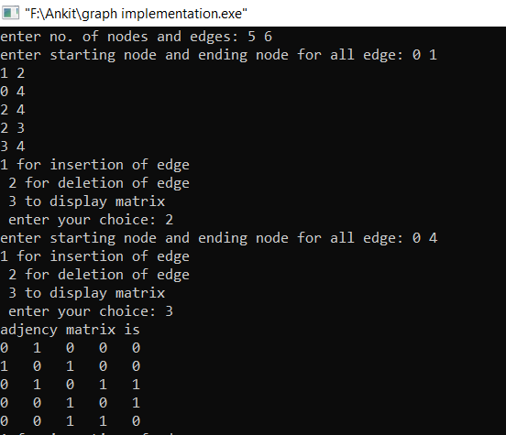

**13.1(a) WAP to find Path matrix using Powers of matrix.**

#include<bits/stdc++.h>

using namespace std;

struct node

{

int data,state;

};

struct graph

{

int v,e,**matrix;

node **nodes;

};

graph* create()

{

graph *temp=new graph;

int i,j,x;

cout<<"enter the no. of vertices :";

cin>>temp->v;

temp->matrix=(int**)malloc(sizeof(int)*(temp->v));

for(i=0;i<temp->v;i++)

temp->matrix[i]=new int[temp->v];

int mat[temp->v][temp->v];

temp->nodes=(node**)malloc(sizeof(node)*temp->v);

for(i=0;i<temp->v;i++)

{

node *y=new node;

cout<<"enter the data of node :";

cin>>y->data;

y->state=0;

temp->nodes[i]=y;

}

cout<<1;

for(i=0;i<temp->v;i++)

for(j=0;j<temp->v;j++)

temp->matrix[i][j]=0;

for(i=0;i<temp->v;i++)

temp->matrix[i][i]=0;

cout<<"enter the no of edges :";

cin>>temp->e;

cout<<"enter source and destination of edges:";

for(x=0;x<temp->e;x++)

{

cin>>i>>j;

int k;

temp->matrix[i-1][j-1]=1;

}

return temp;

}

int** path(graph *temp)

{

int i,j,k,l,t[temp->v][temp->v];

int **path=(int**)malloc(sizeof(int)*(temp->v));

for(i=0;i<temp->v;i++)

path[i]=new int[temp->v];

int **path1=(int**)malloc(sizeof(int)*(temp->v));

for(i=0;i<temp->v;i++)

path1[i]=new int[temp->v];

for(i=0;i<temp->v;i++)

{

for(j=0;j<temp->v;j++)

{

path[i][j]=temp->matrix[i][j];

path1[i][j]=temp->matrix[i][j];

}

}

for(l=0;l<(temp->v)-1;l++)

{

for(i=0;i<temp->v;i++)

{

for(j=0;j<temp->v;j++)

{

int sum=0;

for(k=0;k<temp->v;k++)

{

sum=sum+(path[i][k]*(temp->matrix[k][j]));

}

t[i][j]=sum;

}

}

for(int m=0;m<temp->v;m++)

{

for(int n=0;n<temp->v;n++)

{

path[m][n]=t[m][n];

path1[m][n]=path[m][n]+path1[m][n];

}

}

}

return path1;

}

int main()

{

int i,j;

graph *head=create();

for(i=0;i<head->v;i++)

{

for(j=0;j<head->v;j++)

{

cout<<head->matrix[i][j]<<" ";

}

cout<<"\n";

}

int **p=path(head);

cout<<"\npath matrix :\n";

for(i=0;i<head->v;i++)

{

for(j=0;j<head->v;j++)

{

cout<<p[i][j]<<" ";

}

cout<<"\n";

}

}

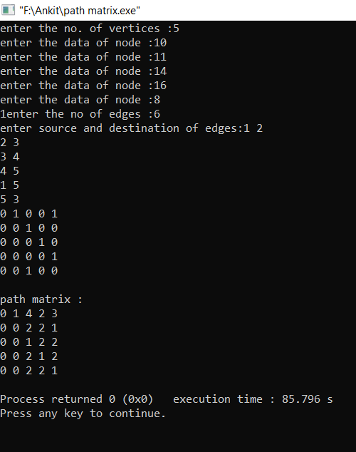

**13.1(b) WAP to find Path matrix using Warshall algorithm.**

#include<bits/stdc++.h>

using namespace std;

struct node

{

int data,state;

};

struct graph

{

int v,e,**matrix;

node **nodes;

};

graph* create()

{

graph *temp=new graph;

int i,j,x;

cout<<"enter the no. of vertices :";

cin>>temp->v;

temp->matrix=(int**)malloc(sizeof(int)*(temp->v));

for(i=0;i<temp->v;i++)

temp->matrix[i]=new int[temp->v];

int mat[temp->v][temp->v];

temp->nodes=(node**)malloc(sizeof(node)*temp->v);

for(i=0;i<temp->v;i++)

{

node *y=new node;

cout<<"enter the data of node :";

cin>>y->data;

y->state=0;

temp->nodes[i]=y;

}

cout<<1;

for(i=0;i<temp->v;i++)

for(j=0;j<temp->v;j++)

temp->matrix[i][j]=99999;

for(i=0;i<temp->v;i++)

temp->matrix[i][i]=0;

//temp->matrix=(int**)mat;

cout<<"enter the no of edges :";

cin>>temp->e;

cout<<"enter source and destination of edges:";

for(x=0;x<temp->e;x++)

{

cin>>i>>j;

int k;

cout<<"enter the weight of node:";

cin>>k;

temp->matrix[i-1][j-1]=k;

//temp->matrix[j-1][i-1]=1;

}

return temp;

}

void floyd_short(graph *head)

{

int i,j,k;

for(i=0;i<head->v;i++)

{

for(j=0;j<head->v;j++)

{

for(k=0;k<head->v;k++)

{

if(head->matrix[i][k]+head->matrix[k][j]<head->matrix[i][j])

{

head->matrix[i][j]=head->matrix[i][k]+head->matrix[k][j];

}

}

}

}

}

int main()

{

graph *head=create();

floyd_short(head);

for(int i=0;i<head->v;i++)

{

for(int j=0;j<head->v;j++)

{

cout<<setw(10)<<head->matrix[i][j]<<" ";

}

cout<<"\n";

}

}

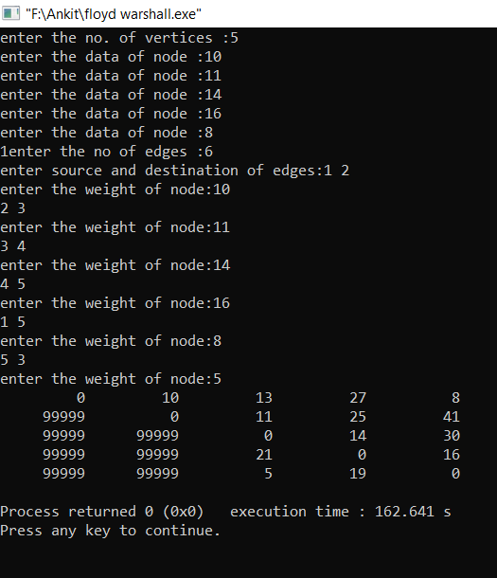

**13.2 Write Functions to perform:**

1. **Breadth First Search**
2. **Depth First Search**

#include<bits/stdc++.h>

using namespace std;

struct node

{

int data,state;

};

struct graph

{

int v,e,**matrix;

node **nodes;

};

struct arraystack

{

int top,cap;

int *no;

};

struct arrayqueue

{

int base,rear,cap,*no;

};

arrayqueue* create_q(int n)

{

arrayqueue *temp=new arrayqueue;

temp->base=-1;

temp->rear=-1;

temp->cap=n;

temp->no=new int[n];

}

bool full(arrayqueue *head)

{

if((head->rear+1)%head->cap==head->base)

return 1;

return 0;

}

bool blank(arrayqueue *head)

{

if(head->base==-1)

return 1;

else

return 0;

}

void enqueue(arrayqueue *head,int n)

{

if(!full(head))

{

head->rear=(head->rear+1)%head->cap;

head->no[head->rear]=n;

if(head->base==-1)

head->base=head->rear;

}

}

int dequeue(arrayqueue *head)

{

if(!blank(head))

{

int n=head->no[head->base];

if(head->base==head->rear)

head->base=head->rear=-1;

else

head->base=(head->base+1)%head->cap;

return n;

}

}

arraystack* create(int n)

{

arraystack *temp=new arraystack;

temp->top=-1;

temp->cap=n;

temp->no=(int*)malloc(sizeof(int)*n);

return temp;

}

bool full(arraystack *head)

{

if(head->top+1==head->cap)

return 1;

return 0;

}

bool blank(arraystack *head)

{

if(head->top==-1)

return 1;

return 0;

}

void push(arraystack *head,int n)

{

if(!full(head))

{

head->top++;

head->no[head->top]=n;

}

}

int pop(arraystack *head)

{

int n;

if(!blank(head))

{

n=head->no[head->top];

head->top--;

return n;

}

}

graph* create()

{

graph *temp=new graph;

int i,j,x;

cout<<"enter the no. of vertices :";

cin>>temp->v;

temp->matrix=(int**)malloc(sizeof(int)*(temp->v));

for(i=0;i<temp->v;i++)

temp->matrix[i]=new int[temp->v];

int mat[temp->v][temp->v];

temp->nodes=(node**)malloc(sizeof(node)*temp->v);

for(i=0;i<temp->v;i++)

{

node *y=new node;

cout<<"enter the data of node :";

cin>>y->data;

y->state=0;

temp->nodes[i]=y;

}

for(i=0;i<temp->v;i++)

for(j=0;j<temp->v;j++)

temp->matrix[i][j]=0;

//temp->matrix=(int**)mat;

cout<<"enter the no of edges :";

cin>>temp->e;

cout<<"enter source and destination of edges:";

for(x=0;x<temp->e;x++)

{

cin>>i>>j;

temp->matrix[i-1][j-1]=1;

temp->matrix[j-1][i-1]=1;

}

return temp;

}

void dfs(graph *head)

{

int i;

arraystack *s=create(head->v);

for(i=0;i<head->v;i++)

{

if(head->nodes[i]->state==0)

{

head->nodes[i]->state=1;

push(s,i);

}

while(!blank(s))

{

int x=pop(s),j;

cout<<head->nodes[x]->data<<" ";

head->nodes[x]->state=2;

for(j=0;j<head->v;j++)

{

//cout<<head->matrix[x][j];

if(head->matrix[x][j]==1)

{

//cout<<2;

if(head->nodes[j]->state==0)

{

head->nodes[j]->state=1;

push(s,j);

}

}

}

}

}

}

void bfs(graph *head)

{

int i,j;

arrayqueue *q=create_q(head->v);

for(i=0;i<head->v;i++)

{

if(head->nodes[i]->state==0)

{

head->nodes[i]->state=1;

enqueue(q,i);

}

while(!blank(q))

{

int x=dequeue(q);

if(head->nodes[x]->state!=2)

{

cout<<head->nodes[x]->data<<" ";

head->nodes[x]->state=2;

}

for(j=0;j<head->v;j++)

{

if(head->matrix[x][j]==1)

{

if(head->nodes[j]->state==0)

{

head->nodes[i]->state=1;

enqueue(q,j);

}

}

}

}

}

}

int main()

{

graph *head=create();

cout<<"bfs:\n";

bfs(head);

int i=0;

while(i<head->v)

{

head->nodes[i]->state=0;

i++;

}

cout<<"\n";

cout<<"dfs:\n";

dfs(head);

}

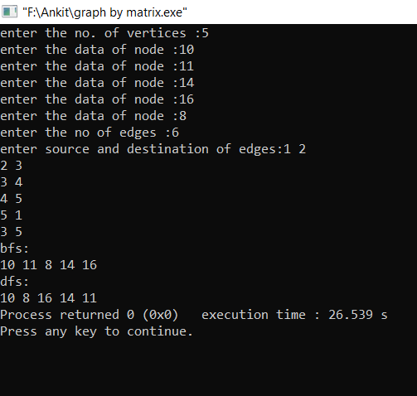

**13.3 Find the shortest path in graph using Dijkstra’s algorithm.**

#include<bits/stdc++.h>

using namespace std;

struct node

{

int data,state;

};

struct graph

{

int v,e,**matrix;

node **nodes;

};

graph* create()

{

graph *temp=new graph;

int i,j,x;

cout<<"enter the no. of vertices :";

cin>>temp->v;

temp->matrix=(int**)malloc(sizeof(int)*(temp->v));

for(i=0;i<temp->v;i++)

temp->matrix[i]=new int[temp->v];

int mat[temp->v][temp->v];

temp->nodes=(node**)malloc(sizeof(node)*temp->v);

for(i=0;i<temp->v;i++)

{

node *y=new node;

cout<<"enter the data of node :";

cin>>y->data;

y->state=0;

temp->nodes[i]=y;

}

for(i=0;i<temp->v;i++)

for(j=0;j<temp->v;j++)

temp->matrix[i][j]=0;

cout<<"enter the no of edges :";

cin>>temp->e;

cout<<"enter source and destination of edges:";

for(x=0;x<temp->e;x++)

{

cin>>i>>j;

cout<<"enter weight :";

int k;

cin>>k;

temp->matrix[i-1][j-1]=k;

}

return temp;

}

int minDistance(int dist[], bool sptSet[],int n)

{

int min = INT_MAX, min_index;

for (int v = 0; v < n; v++)

if (sptSet[v] == false && dist[v] <= min)

min = dist[v], min_index = v;

return min_index;

}

int print(int dist[], int n)

{

cout<<("Vertex Distance from Source\n");

for (int i = 0; i < n; i++)

cout<<i<<" distance ="<<dist[i]<<" \n";

}

void dijkstra(graph* head, int src)

{

int V=head->v;

int dist[V];

bool sptSet[V];

for (int i = 0; i < V; i++)

dist[i] = INT_MAX, sptSet[i] = false;

dist[src] = 0;

for (int count = 0; count < V-1; count++)

{

int u = minDistance(dist, sptSet,head->v);

sptSet[u] = true;

for (int v = 0; v < V; v++)

if (!sptSet[v] && head->matrix[u][v] && dist[u] != INT_MAX

&& dist[u]+head->matrix[u][v] < dist[v])

dist[v] = dist[u] + head->matrix[u][v];

}

print(dist, V);

}

int main()

{

graph *head=create();

dijkstra(head, 0);

return 0;

}

